Sept 4 2025 BDBP106: Linux and Python Programming Lab 14

Use only the math module if necessary for these exercises.

1. **Arithmetic operations and operator precedence** Predict and check your results for the following arithmetic operations

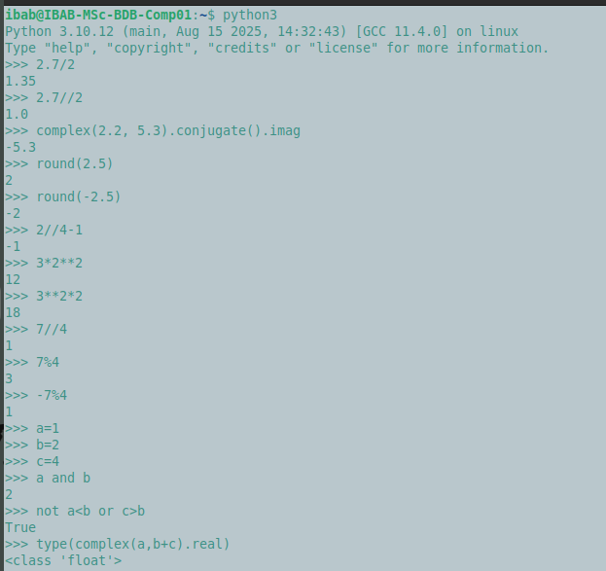

1. **Logical operations** Predict and check your results for the following boolean operations.

Assign the values 1,2,4 respectively to a,b and c and do the following

* 1. a and b
  2. not a*<*b or c*>*b
  3. type(complex(a,b+c).real) is int



1. For any input integer k and another input integer n where *n >* 0 write a small code that prints the results of all arithmetic operations between k and n. You need to be able to save your code in a program and run it for this and the next problem. In fact the rest of the labs will involve a lot of writing programs in files. Running the python shell helps testing small stuff, not for lengthy codes.

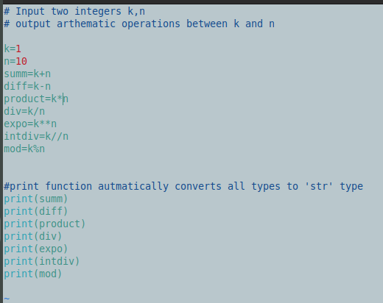

1. Input real numbers a,b and c. Treating these as coefficients of the quadratic equation

*ax*2 + *bx* + *c* = 0 find and print the roots.

